PLACE VALUE
1000s 100s 10s 1s
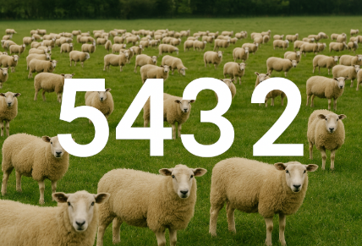

SECTION ONE
This is a picture the farmer took to remind her of how many sheep she has.
- How many sheep does the farmer have?
SAY THE NUMBER OUT LOUD

- How many thousands of sheep does the farmer have?

Thousands

- How many hundreds are there in the number of sheep the farmer has?

Hundreds

- How many tens are there in the number of sheep the farmer has?

Tens

- How many ones (units) are there in the number of sheep the farmer has?
Units

************MOVEMENT BREAK**************

Walk on the spot counting in 10s up to 100!

SECTION ONE ACHIEVED
DATE:
Print pages 1 to 4 and place a sticker in the box.
WELL DONE

SECTION TW0
Place values about your house Chartwell.
- Say this number out loud: 2009
- In the box below, copy and paste a picture from Google Earth showing your house in year 2009.

- Write the date this picture was taken in the boxes below:
Units

Tens

Hundreds

Thousands

- Copy your 2009 picture again into box 1 below:
1.

Now find a more recent picture of your house on Google Earth and copy this one into box 2.
2.

What year was the picture in box 2 taken?
Units

Tens

Hundreds

Thousands

How many differences can you spot between the two pictures?
Units

Tens

Hundreds

Thousands

************MOVEMENT BREAK**************
Walk on the spot counting in 100s up to 1000!

SECTION TWO ACHIEVED
DATE:
Print pages 5 to 8 and place a sticker in the box.
WELL DONE

LOOK BACK OVER ALL YOUR EIGHT PAGES AND READ THE NUMBERS OUT LOUD.

PRINT OUT JUST THE NEXT PAGE

SECTION FOUR
COLLECT THE NUMBERS FROM PAGES 1 TO 8 AND PLACE THEM IN THE CORRECT COLUMNS BELOW
THOUSANDS HUNDREDS TENS UNITS
________________________________________________________________________________________________________________________________________________________________________________________________________________________________________________________________________________________________________________________________________________________________________________________________________________________________________________________________________________________________________________________________________

SECTION FIVE
- Put the HP of these three tractors in order:
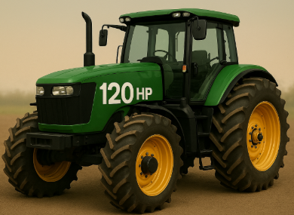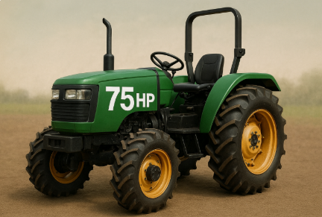
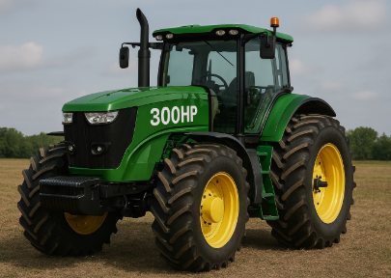

MOST HP MIDDLE HP LEAST HP

And these…. 250HP 100 HP 150 HP

MOST HP MIDDLE HP LEAST HP

And these…. 25HP 100 HP 75 HP

MOST HP MIDDLE HP LEAST HP

- This is my grass field. It is 20 acres.
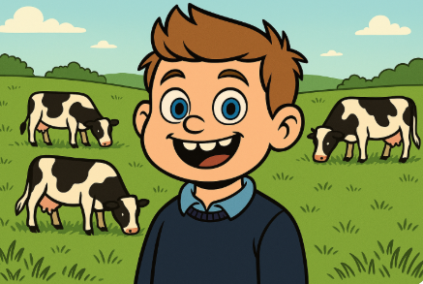

This is my wheat field. It is 100 acres.
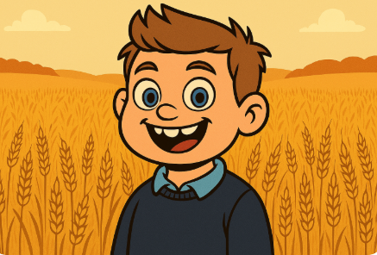
My other fields are 60 acres and 90 acres.

Place them in order- largest to smallest:

How many acres do I have in all?
Total | 0

What is this rounded up to the nearest hundred?
Hint the numbers 5-6-7-8-9 would all round up to 10.
The numbers 55, 56, 57, 58, and 59 would all round up to 60
The numbers 150-160-170-180-190 would all round up to 200. Which means that they are rounded up to the nearest hundred.

- How many chickens are there in this picture?
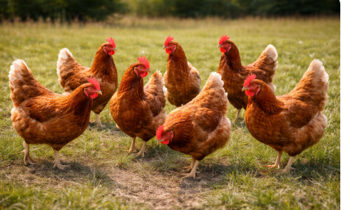

How many chickens rounded up to the nearest ten?

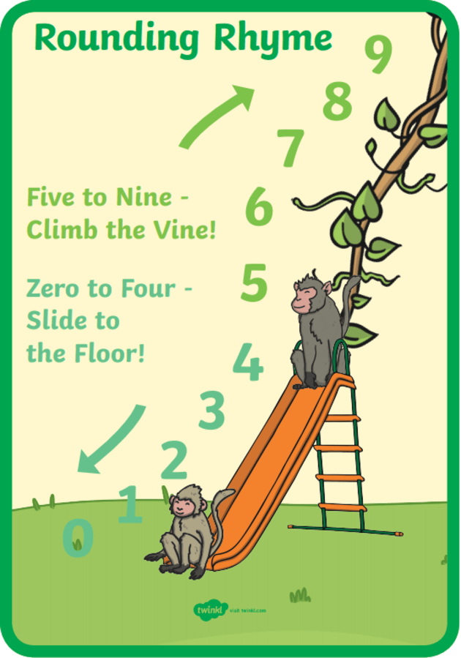

- I have 399 chickens- what is this rounded up to the nearest hundred?
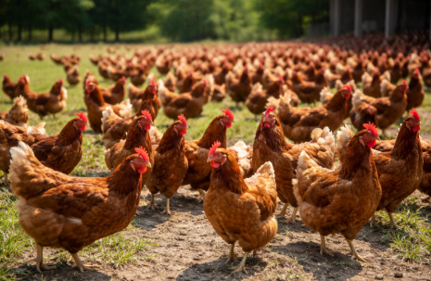

************MOVEMENT BREAK**************
Pretend you are climbing a ladder.
Climb up the ladder counting out loud from 5 to 10.
Climb down the ladder counting from 4 down to 0. REPEAT THREE TIMES
SECTION FIVE ACHIEVED
DATE:
Print pages 10 to 17 and place a sticker in the box.
WELL DONE

1. Number & Place Value quick Probe
- On Farmer Tom’s land there are 3,476 sheep.
  - What digit is in the hundreds place?

- Order these herd sizes from smallest to largest:
4,210 cows, 3,998 cows, 4,005 cows.

- Round 2,867 chickens to the nearest hundred.

- Count forward in 100s starting from 1,500, four steps.

- Which is greater: a tractor that can pull 2,450 kg or 2,540 kg?
Answer: The tractor that can pull kg

SECTION SIX
PUT THESE NUMBERS INTO THEIR CORRECT COLUMNS BELOW: 1 10 100 1000

 | 1000s | 100s | 10s | Units
1
10
100
1000
And now these numbers:
36
21
32
Now let’s try adding these:
36
21
32
 |  |  | 8 | 9

CAN YOU SEE HOW WE USED TO COLUMN METHOD TO ADD THEM UP?

Now let’s try adding these:
11
12
16
 | 0 | 0 | 0 | 0

Now let’s try adding these:
111
12
16
 | 0 | 0 | 0 | 0

Now let’s try adding these:
111
112
16
 | 0 | 0 | 0 | 0




A luxury car company sells 36 Jaguar models each year.
It also sells 21 Mercedes and 32 BMWs each year.
How many luxury cars does it sell in total each year?

=

************MOVEMENT BREAK**************
We are going to create three car parks. You will see some toy cars and each has a number in words on top.
Drive the cars into the correct car park.
(‘One thousand, One hundred, Ten, One’)
SECTION SIX ACHIEVED
DATE:
Print pages 18 to 22 and place a sticker in the box.
WELL DONE

MY CAN-DO LIST

I understand place values.
I can round numbers up.

I can use the column method to add numbers.

Grab a tick and paste it into the box:


